**Copyright 2025 The MathWorks, Inc.**

**Troubleshoot Guide for setting QuestaSim executable on the System Path**

To verify if MATLAB could find QuestaSim executable on the System Path, please execute the following command:

>> !vsim

Reading pref.tcl

# 2021.4

The command result should give you the version of the QuestaSim. Please press ‘Ctrl + C’ after executing the command to close the vsim call.

If version cannot be detected, then you can add the QuestaSim executable path to the Environment Variables by following steps: (for Windows)

1. Save and close all active MATLAB sessions.
2. Search and open ‘Edit the system environment variables’ from Windows start menu.

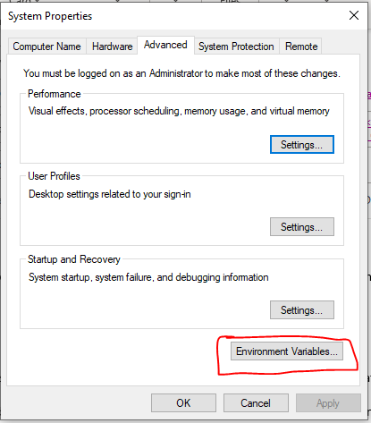

1. Click on ‘Environment Variables’, select ‘Path’ variable and click Edit.

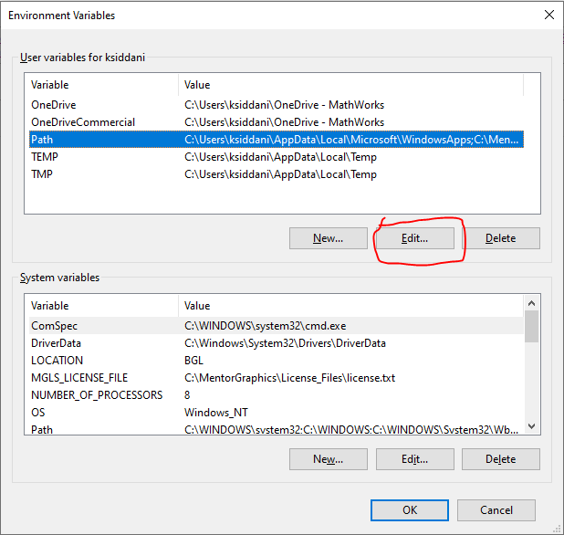

1. Add the path of QuestaSim executable to the list. If you have multiple versions of QuestaSim, the first one in this list will be used.

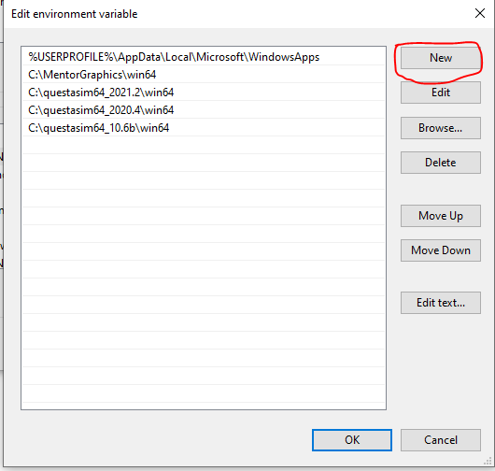

1. Open MATLAB, test following command:

>> getenv('Path')

This should show the environment variable ‘Path’ and its values separated by ‘;’. The list should have the QuestaSim executable path that you have added.

1. If path can be seen in the result, proceed to perform HDL Cosimulation.